Question No. 1

The diagram given below is representing the Bipolar-AMI signal encoding scheme. You are required to carefully analyze the diagram and then write down the binary pattern represented by the diagram.

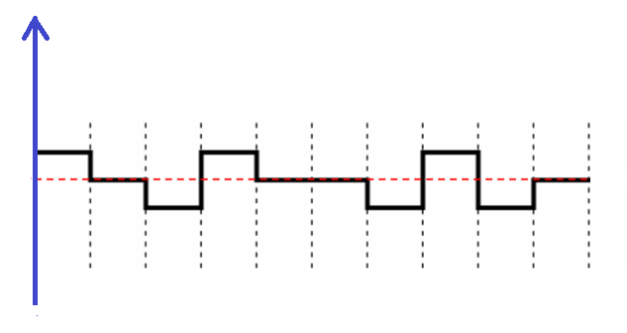

Answer:

1 | 0 | 1 | 1 | 0 | 0 | 1 | 1 | 1 | 0

Question No. 2

What is the Nyquist sampling rate for each of the following signals?

- A low-pass signal with bandwidth of 150 KHz?

Answer a:

As per Nyquist Sampling Rate, Sampling size should be 2x of the highest frequency,

Therefore,

Signal Bandwidth = 150 KHz

1 KHz = 1000 Hz

So,
Signal Bandwidth = 150x1000 = 150,000 Hz

Sampling Rate = 2x Bandwidth samples/second

= 2 x 150,000

= 300,000 samples/second

- A band-pass signal with bandwidth of 250 KHz if the lowest frequency is 100 KHz?

Answer b:

In this case Bandwidth will be the difference of two frequencies;

f_{h} = 250 KHz
f_{l} = 100 KHz

f_{b} = Fh – Fl
= 250-100
= 150 KHz

So,
Signal Bandwidth (f_{b}) = 150x1000 = 150,000 Hz

Sampling Rate = 2x Bandwidth samples/second

= 2 x 150,000

= 300,000 samples/second

